CPE
6 Hrs

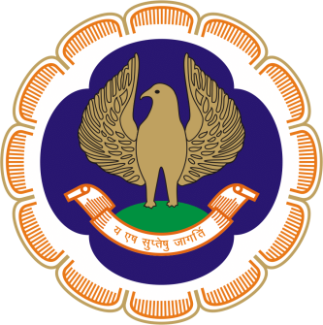

The Chairman & The Managing Committee
of
Thiruvananthapuram Branch of SIRC of ICAI

Cordially invite you
for a One Day Tax Audit Seminar
On Saturday, 16th September 2019
at Suri Centinary Hall, ICAI Bhawan, Thiruvananthapuram

PROGRAMME

09.30 am - 10.00 am : Registration
Inauguration : CA. Jomon K George, SIRC Chairman

10.00 am – 01.00 pm : In-depth Analysis of Audit under Section 44AB

Faculty : CA. Himanshu Krishnadwala (Mumbai)

01.00 pm – 02.00 pm : Lunch

02.00 pm – 05.00 pm : Analysis of Important clauses of 3CD

Faculty : CA. Jagadish Punjabi (Mumbai)

Registration Fees : ARS Members of Trivandrum Branch - NIL
Non ARS Members - Rs.1000/-
Others - Rs. 1500/- (Inclusive of GST)

CA. Ramakrishnan H CA. Roopesh R
Secretary Chairman

Thiruvananthapuram
06 September 2019

