CPE
3 Hrs

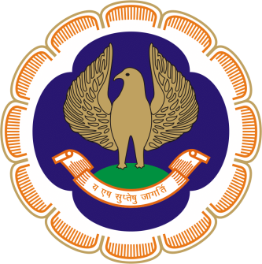

The Chairman & The Managing Committee
of
Thiruvananthapuram Branch of SIRC of ICAI

Cordially invite you
for a CPE Seminar on Forensic Auditing
On Saturday, 26th October 2019
at Suri Centinary Hall, ICAI Bhawan, Thiruvananthapuram

PROGRAMME

09.30 am - 10.00 am : Registration

10.00 am – 01.00 pm : Forensic Auditing

Faculty : CA. Arpit Jagadeesh Kabra (Bombay)

01.00 pm – 02.00 pm : Lunch

Registration Fees : ARS Members of Trivandrum Branch - NIL
Non ARS Members - Rs.600/-
Others - Rs. 1000/- (Inclusive of GST)

CA. Ramakrishnan H CA. Roopesh R
Secretary Chairman

Thiruvananthapuram
16 October2019

